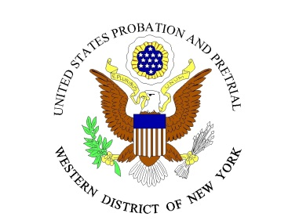
UNITED STATES PROBATION OFFICE
WESTERN DISTRICT OF NEW YORK
Vacancy Announcement No. 21-02

Opening Date: January 25, 2021 Closing Date: February 15, 2021
Position: URINALYSIS TECHNICIAN
Position Location: Western District of New York – Buffalo & Rochester
Salary Range: Classification Level 21
$23,280 - $37,849
Pay Table BU – starting salary is dependent upon qualifications.
Starting Date: February 2021

The U.S. Probation & Pretrial Services Office for the Western District of New York encompasses 17 counties and consists of two offices. There are four district court judges, four senior judges, and seven magistrate judges. The probation office is headquartered in Buffalo and has one division office in Rochester. The vacant position is available in the Buffalo (60%) office and will require travel to the Rochester (40%) office each week.
The Urinalysis Technician is responsible for assisting in the operation, integrity, and efficiency of the court unit’s on-site substance abuse testing program.

Representative Duties:
- Observe and collect urine samples submitted by offenders of the same gender.
- Certify the validity of urine test results and maintain appropriate records.
- Enter testing data in the appropriate database on a daily basis.
- Collect and distribute test results to appropriate staff members.
- Record information for reports and investigations related to drug testing.
- Collect data and complete forms in support of the drug testing program.
- Report all hazardous or safety-related incidents encountered in the course of duty to the appropriate authority.
- Perform other duties as assigned.

Minimum Qualification Requirements:
Applicants must possess high school diploma or equivalent, to qualify for Classification Level 21, Step 1. Within each classification level, an evaluation of quality of experience and competitive factors may provide placement at salary levels above Step 1 up to and including Step 25. Salary placement above Step 1 of the classification is granted at the discretion of the Chief U.S. Probation Officer.

Benefits:
Employees of the United States District Court serve under “Expected Appointment” and are considered “At-Will” employees. Federal Government Civil Service classifications or regulations do not apply. Judicial employees are entitled to the same benefits as other Federal Government employees such as:

- Employees accrue 13 days of paid vacation per year for the first three years
- Ten paid national holidays per year
- Participation in the Federal Employees Health Insurance Program on a pre-tax deduction basis
- Participation in Group Life Insurance
- Participation in the Federal Employees Retirement System with investment opportunities through the Thrift Savings Plan
- Participation in Pre-Tax Flexible Spending Accounts

For more information on working for the federal courts, please visit http://www.uscourts.gov/Careers.aspx.

Background Investigation:
This position is classified as a sensitive position which requires the final candidate to undergo a mandatory local background investigation, FBI fingerprint check and subsequent favorable suitability determination as a condition of employment.

Application Process:
Individuals interested in being considered for the position are invited to submit a cover letter and resume to Holly S. Powell, Human Resources Assistant, HR@nywp.uscourts.gov, by 5:00 PM on February 15, 2021. Job description and additional information can be located on our website at
www.nywp.uscourts.gov.
Applicants must be United States citizens. This position is subject to mandatory Electronic Funds Transfer participation for payment of net pay. Due to the volume of applications received, the U.S. Probation Office will contact only the most qualified applicants who will be invited for interview. Only qualified applicants will be considered for this position. The U.S. Probation Office has the right to modify the conditions of this job announcement, withdraw the announcement or fill the position at any time before the closing date, any of which may occur without prior notice.

The U.S. Probation & Pretrial Services Office is an Equal Opportunity Employer

